**Introduction to Human-Computer Interaction (HCI)**

* Human-computer interaction (HCI) is a multidisciplinary field of study focusing on the design of computer technology and, in particular, the interaction between humans (the users) and computers.
* Initially concerned with computers, but HCI has since expanded to cover almost all forms of information technology design.
* Began in the 1980s with the advent of personal computing, with machines such as the Apple Macintosh, IBM PC 5150 and Commodore 64 started turning up in homes and offices in society-changing numbers.
* For the first time ever, sophisticated electronic systems were available to general consumers for uses such as word processors, games units and accounting aids.
* Consequently, as computers were no longer room-sized, expensive tools exclusively built for experts in specialized environments, the need to create human-computer interaction that was also easy and efficient for less experienced users became increasingly vital.
* From its origins, HCI would expand to incorporate multiple disciplines, such as computer science, cognitive science and human-factors engineering.

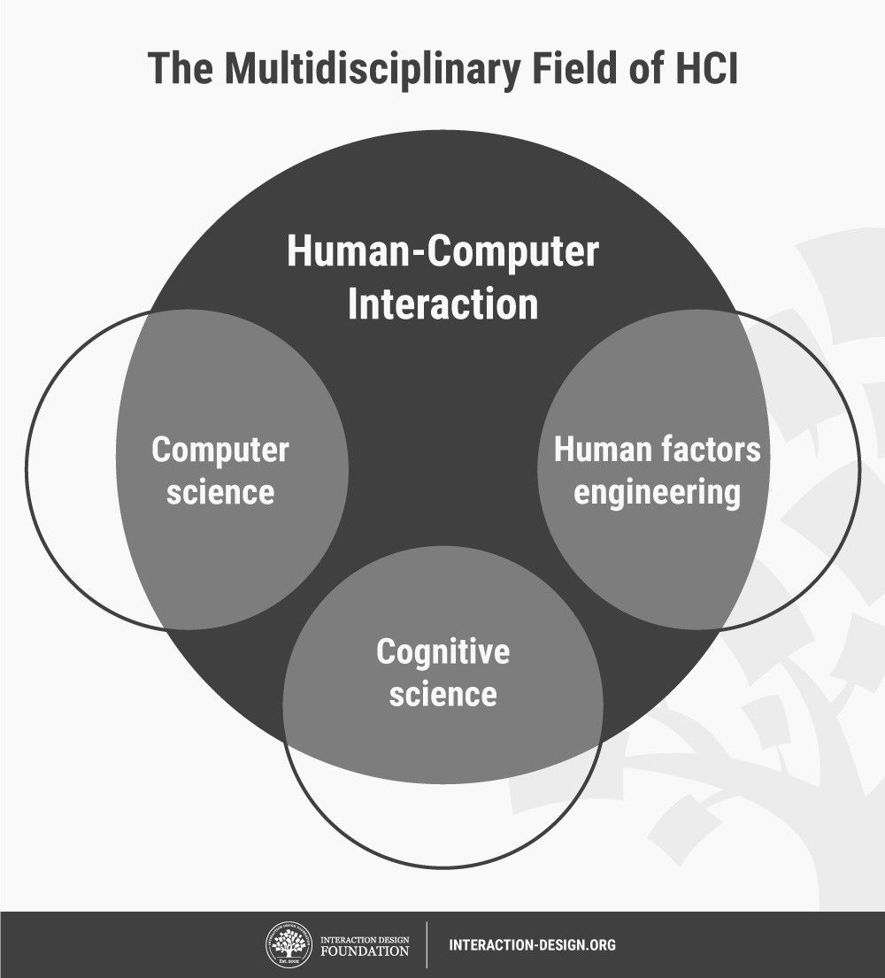

* HCI soon became a subject of intense study in academic institutions. HCI was seen as a crucial instrument to popularize the idea that the interaction between a computer and the user should resemble a human-to-human, open-ended dialogue.
* Initially, HCI researchers focused on improving the usability of desktop computers (i.e., practitioners concentrated on how easy computers are to learn and use). However, with the rise of technologies such as the Internet and the smartphone, computer use would increasingly move away from the desktop to embrace the mobile world.
* Also, HCI has steadily encompassed more fields:
* HCI has expanded from its initial focus on individual and generic user behavior to include social and organizational computing, accessibility for the elderly, the cognitively and physically impaired, and for all people, and for the widest possible spectrum of human experiences and activities.
* It has expanded from desktop office applications to include games, learning and education, commerce, health and medical applications, emergency planning and response, and systems to support collaboration and community.
* It has also expanded from early graphical user interfaces to include myriad interaction techniques and devices, multi-modal interactions, tool support for model-based user interface specification, and a host of emerging ubiquitous, handheld and context-aware interactions.

**HCI and Its Variants**

* HCI is a broad field which overlaps with areas such as user-centered design (UCD), user interface (UI) design and user experience (UX) design.
* In many ways, HCI was the forerunner to UX design.
* Despite that, some differences remain between HCI and UX design. Practitioners of HCI tend to be more academically focused. They're involved in scientific research and developing empirical understandings of users.
* Conversely, UX designers are almost invariably industry-focused and involved in building products or services—e.g., smartphone apps and websites.
* Regardless of this divide, the practical considerations for products that we as UX professionals concern ourselves with have direct links to the findings of HCI specialists about users’ mindsets.
* With the broader span of topics that HCI covers, UX designers have a wealth of resources to draw from, although much research remains suited to academic audiences.
* HCI specialists do more academic research whose findings designers rely on to drive impactful changes in the market and society.

**The Goals of HCI**

The goals of HCI are to produce usable and safe systems, as well as functional systems. In order to produce computer systems with good usability, developers must attempt to:

* understand the factors that determine how people use technology
* develop tools and techniques to enable building suitable systems
* achieve efficient, effective, and safe interaction
* put people first

Underlying the whole theme of HCI is the belief that people using a computer system should come first. Their needs, capabilities and preferences for conducting various tasks should direct developers in the way that they design systems. People should not have to change the way that they use a system in order to fit in with it. Instead, the system should be designed to match their requirements.

**Usability**

Usability is one of the key concepts in HCI. It is concerned with making systems easy to learn and use. A usable system is:

* easy to learn
* easy to remember how to use
* effective to use
* efficient to use
* safe to use
* enjoyable to use

**Why is usability important?**

Many everyday systems and products seem to be designed with little regard to usability. This leads to frustration, wasted time and errors. This list contains examples of interactive products:

*mobile phone, computer, personal organizer, remote control, soft drink machine, coffee machine, ATM, ticket machine, library information system, the web, photocopier, watch, printer, stereo, calculator, videogame etc.*

How many are actually easy, effortless, and enjoyable to use?

For example, a photocopier might have buttons like these on its control panel.

“C”

Imagine that you just put your document into the photocopier and set the photocopier to make 15 copies, sorted and stapled. Then you push the big button with the "C" to start making your copies.

What do you think will happen?

(a) The photocopier makes the copies correctly.

(b) The photocopier settings are cleared and no copies are made.

If you selected (b) you are right! The "C" stands for clear, not copy. The copy button is actually the button on the left with the "line in a diamond" symbol. This symbol is widely used on photocopiers, but is of little help to someone who is unfamiliar with this.

**Factors to Consider in HCI**

There are a large number of factors which should be considered in the analysis and design of a system using HCI principles. Many of these factors interact with each other, making the analysis even more complex. The main factors are listed in the table below:

***Organisation Factors***

Training, job design, politics, roles, workorganisation

***Environmental Factors***

Noise, heating, lighting, ventilation

***Health and Safety Factors***

***The User***

* Cognitive processes and capabilities
* Motivation, enjoyment, satisfaction, personality, experience
* Comfort Factors
* Seating, equipment, layout.

***User Interface***

Input devices, output devices, dialogue structures, use of colour, icons, commands, navigation, graphics, natural language, user support, multimedia,

***Task Factors***

Easy, complex, novel, task allocation, monitoring, skills

***Constraints***

Cost, timescales, budgets, staff, equipment, buildings

***System Functionality***

Hardware, software, application

***Productivity Factors***

Increase output, increase quality, decrease costs, decrease errors, increase innovation

**Disciplines contributing to HCI**

As earlier stated, the field of HCI covers a wide range of topics, and its development has relied on contributions from many disciplines. Some of the main disciplines which have contributed to HCI are:

***Computer Science***

* technology
* software design, development & maintenance
* User Interface Management Systems (UIMS) & User Interface Development Environments (UIDE)
* prototyping tools
* graphics

***Cognitive Psychology***

* information processing
* capabilities
* limitations
* cooperative working
* performance prediction

***Social Psychology***

* social & organizational structures
* Ergonomics/Human Factors
* hardware design
* display readability

***Linguistics***

* natural language interfaces

***Artificial Intelligence***

* intelligent software

***Philosophy, Sociology & Anthropology***

* Computer supported cooperative work (CSCW)

***Engineering & Design***

* graphic design
* engineering principles